Name ________________________________________ Hour _____

Titration of an Acid and a Base
(Honors Chemistry)
Objectives
- To observe the quantity of solution remaining in a burette when the equivalence point is reached
- To gain experience in calculating the Molarity of an unknown solution.
Materials  - Solution of 0.1-M NaOH  - Solution of HCl - A (Unknown concentration)  - Solution of HCl - B (Unknown concentration)  - Solution of HCl - C (Unknown concentration)  - Phenolphthalein indicator  - Erlenmeyer Flask, 125 mL  - Burette  - Burette Clamp  - Ring Stand  - 10-mL graduated cylinder  - 100-mL beaker | 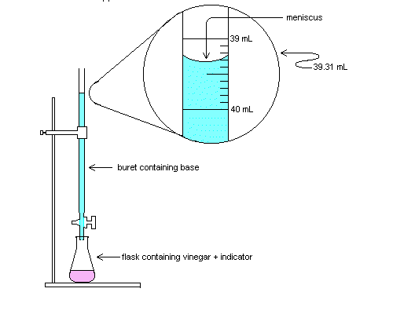  Burette containing Base  Flask containing acid and indicator
Procedure
- Set up the apparatus as shown above.
- Place approximately 50-mL of NaOH solution into a clean, dry beaker.
- Obtain exactly 10-mL of HCl – A in a 10-mL graduated cylinder.
- Pour the 10-mL of HCl – A into a clean Erlenmeyer flask.
- Add 20-mL of distilled water to the Erlenmeyer flask. (This volume will not be used in your calculations!)
- Add 2 drops of phenolphthalein indicator to the Erlenmeyer flask containing the HCl solution.
- Add 50-mL of 0.1-M NaOH to the Burette.
- Place the flask under the Burette.
- Turn the stopcock and begin to slowly add NaOH to the HCl. Go very slow!
- As you are adding the NaOH to the HCl, swirl the flask gently to mix the acid and base.
- When the indicator changes color, immediately stop adding NaOH to the flask.
- Record your results in the table below.
- Repeat steps 3 – 12 for determining the concentration of HCl – B and HCl – C

Perform all work on this back of this page and then fill in the chart below:
 | HCl - A | HCl - B | HCl - C
Molarity of NaOH
Volume of NaOH
Moles of NaOH
Molarity of HCl
Volume of HCl
Moles of HCl

- Write a balanced equation for the acid-base reaction that occurred during the titration.

- How many milliliters of 0.1-M NaOH solution was needed to neutralize the 10-mL of HCl solution?

HCl-A | HCl-B | HCl-C

3. How many moles of NaOH were needed to neutralize the HCl solution? Show your work!

HCl-A | HCl-B | HCl-C

4. How many moles of HCl were present in the HCl solution? Show your work!

HCl-A | HCl-B | HCl-C

5. What is the molarity of the 10-mL of unknown HCl solution? Show your work!

HCl-A | HCl-B | HCl-C

6. Fill in the table on the front of the page with the answers to questions 2 – 5.

